VDF OCP Uniform Specifications

Below are images and a list of compliant VDF OCP uniforms and accoutrement. Links below are suggestions. Other options may be available.
Non-compliant uniforms will not be authorized to wear.
Direct questions to your chain of command.

- Cover: Olive Drab Green ball cap, 100% cotton Ripstop, hook-and-loop on the back bottom of cover for name tape, flexible bill, made in the USA, AR 670-1 compliant. Quantity: Two.
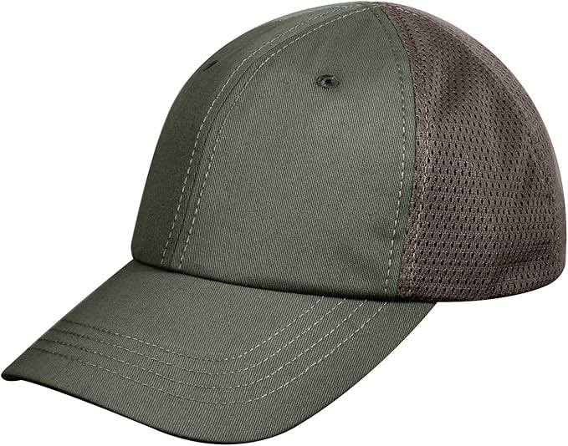

Link: Rothco

- Blouse: True Spec OCP shirt, Zippered front closure, reinforced with hook-and-loop, Mandarin collar with Hook-and-loop closure. Can be worn open or closed, Slanted arm pockets on each arm with hook-and-loop panel for attachment of patches, Slanted chest pockets with hook-and-loop closures,3-slot pen pocket on lower arm, Hook-and-loop adjustable cuffs, Hook-and-loop is provided on chest for name tapes and rank patches, Elbow patch reinforcements on each arm which open with hook-and-loop for padding, Made of 100% Cotton (Ripstop), Made in the USA. Quantity: Two.
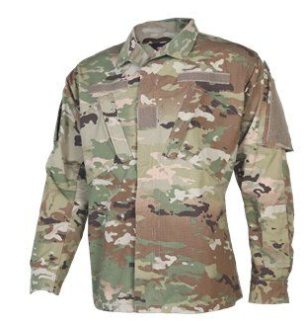
Link: Tactical Gear

- Pants: OCP trousers, Button fly, two front hand pockets, two rear button-down pockets, T OCP trousers, Button fly, Two front hand pockets, Two rear button-down pockets, Two slanted cargo style pockets with concealed Hook-and-loop closure flap, Toggles on elastic shock cords for each leg pocket, Two lower leg pockets with concealed Hook-and-loop closure, Reinforced seat for longer wear, Knee patch reinforcements on each knee which open with Hook-and-loop for padding, Button waist with pull adjuster belt inside, Internal drawstring tie bottoms, Belt loops, Made of 100% Cotton (Ripstop), Made in the USA. two slanted cargo style pockets with concealed Hook-and-loop closure flap, Toggles on elastic shock cords for each leg pocket, two lower leg pockets with concealed Hook-and-loop closure, Reinforced seat for longer wear, Knee patch reinforcements on each knee which open with Hook-and-loop for padding Button.
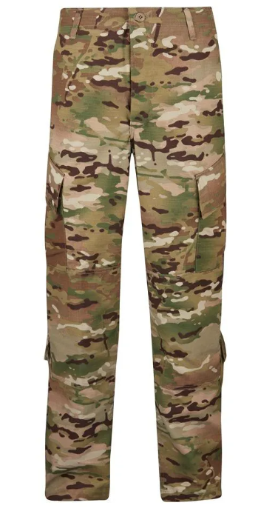

Link: Tactical Gear

- T-Shirt: AR 670-1 compliant for US military wear, coyote brown, material 3.8oz., 100% polyester, Posi change technology, removeable tag, set-in sleeves, made in the USA. Quantity Four.
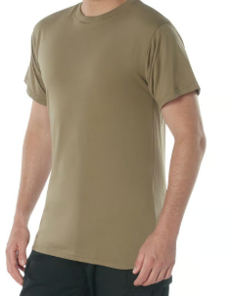

Link: Tactical Gear

- Virginia Flag: VA Flag, blue background, hook and loop, Made in the USA.
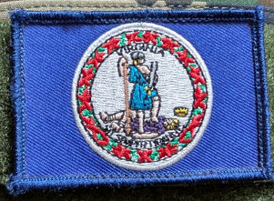
Link: 1800Nametapes

- Virginia Defense Force Patch: Virginia Defense Force patch, full color, maroon background, hook and loop, made in the USA.
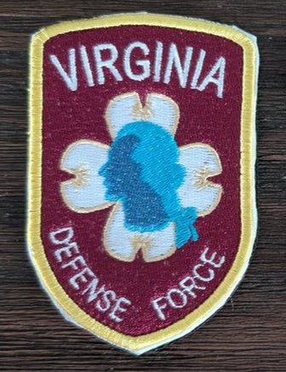
Link: 1800NameTapes
Contact # & email: 1-800-626-3827 / office@1800nametape.com

- SDF Patch
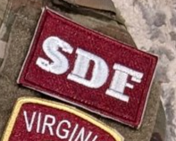

Link: 1800NameTapes
Contact # & email: 1-800-626-3827 / office@1800nametape.com

- State Name Tape: VIRGINIA with maroon background and white lettering, hook and loop, made in the USA, AR 670-1 compliant.
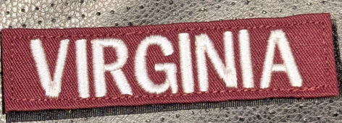
Link: 1800Nametapes
The above link is for hook and loop. If sew-on is desired, click here.
Order “Virginia”. Be sure to have THREAD COLOR AS WHITE.

- Name Tape: Name tape with maroon background with white lettering, hook and loop, made in the USA, AR 670-1 compliant. Quantity: 4 tapes.
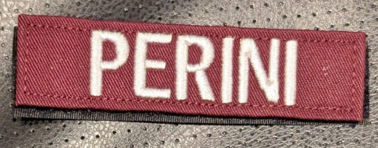
Link: 1800Nametapes
The above link is for hook and loop. If sew-on is desired, click here.
Order your last name. Be sure to have THREAD COLOR AS WHITE.

- Rank, Velcro: Subdued, maroon background with white rank, hook and loop, U.S. Army rank, made in the USA, AR 670-1 compliant. MAJ and 2LT will have gold rank. MAJ seen below. Quantity: 4 Pin on.
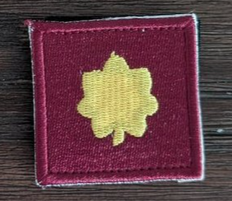

Link: 1800NameTapes
Contact # & email: 1-800-626-3827 / office@1800nametape.com

- Rank, Pin on: Non-subdued, Pin on, U.S. Army rank, made in the USA, AR 670-1 compliant. Quantity: 4.

Link: Vanguard

Find your rank under “Branch,” and “Army.” Enlisted and Officer are separate.

- Belt: AR 670-1 compliant riggers belt, coyote brown, nylon belt, aluminum buckle, 1 7/8" buckle, 1 3/4" belt, hook and loop closures and fasteners, Made in the USA. Quantity: one.
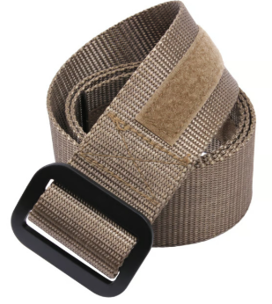

Link: Tactical Gear

- Socks: Coyote brown, premium cotton/ nylon blend, made in the USA, military grade tactical boot socks, half cushioned foot and reenforced leg to provide optimal comfort and fit, ribbed support top, moisture wicking. Quantity Four Pair.

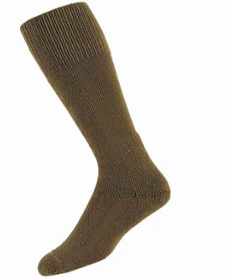

Link: Tactical Gear

- Cold Weather Jacket: Able to be worn as a jacket or liner inside the jacket, 100% polar fleece, full front zipper zips through the collar, neck, shoulder, elbow patches are 100% nylon for durability, gridded side/armpit panels promotes breathability, hook and loop panels for rank and name tape attachment, 2 outer side pockets for accessory storage, 2 inside pockets mesh pockets to secure valuables, made in the USA, Quantity: one.

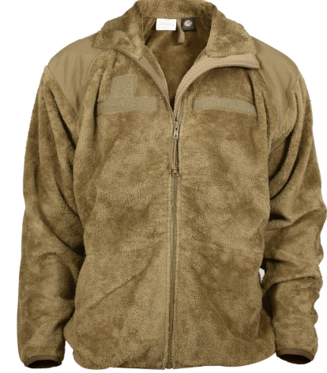

Link: Tactical Gear

- Wet Weather Jacket: OCP H2O proof 2nd Gen ECWCS Parka, AR 670-1 compliant, freeze proof zipper, standing color, stowable hood, drawstring waist w/ cord lock, bicep pockets with flap closure zippered ventilation under arms, adjustable sleeve cuffs, hook and loop panels for patches on the shoulder sleeves and on the front for name tapes and rank, hidden pockets for maps. H2O shell fabric with Bemis seal tapes, Advanta liner, reenforced nylon elbows, Made in the USA. Quantity: One.
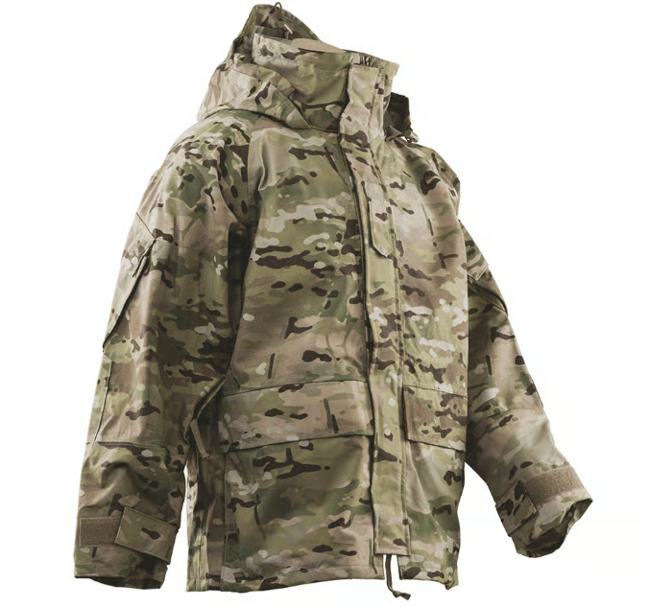

Link: Amazon

- Wet Weather Pants: OCP H2O proof 2nd Gen ECWCS Pants, AR 670-1 compliant, Dentex inner lining, zipper fly w/ snap button, Bemis seem tapes, reinforced knees, two pass through pockets, drawstring waist with cord lock, zipper leg openings w/ hook and loop adjustments on the ankles, Made in the USA. Quantity: One.

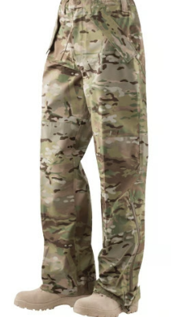

Link: USPatriot

- Gloves: Coyote Brown, touchscreen compatible, synthetic suede palm with full textured grip overlay, adjustable hook and loop wrist closure, reinforced cuff seem/ pull tab, molded breathable neoprene knuckle, 4 way stretch breathable top, neoprene wrist keeps out moisture and debris, TAA compliant, EU Material available, nylon Ribspan back of the hand, synthetic suede palm, made in the USA, Waterproof, Quantity: 1 pair

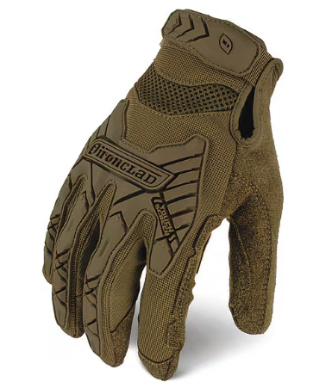

Link: Amazon

- Boots: Coyote brown, flash and water resistant leather, proprietary high walled Vibram soles, with perforated, air-port footbed, and PU midsoles, 1000 Danner Cordura, triple stitched construction, drainage vents, leather instep panel, fiberglass shank, advanced C2V sieve technology circulates air in and water out, 8 inches in height, reduces injuries with roll stop stability, weighs 4 Lbs. per pair, approved wear with all applicable OCP variations, uniform compliant with DA pamphlet 670 dated 1 July 15, ASTM F2413-11 & ASTM F2412-11 protective toe classification, ASTM F2413-11 & ASTM F2412-11 electrical hazard standard, made in the USA, coated with flame resistance, intended for military use, made with PFS chemicals. Made in the USA. Quantity: two pairs.
